Project Design Phase
Solution Architecture

Date | 19 February 2026
Team ID | LTVIP2026TMIDS62122
Project Name | Startup Success Prediction System Using Machine Learning
Maximum Marks | 4 Marks

Solution Architecture:
The solution architecture for the Startup Success Prediction System bridges the gap between the business problem of startup uncertainty and a reliable technology-driven solution. The primary objective of the architecture is to identify and implement the most suitable technological framework to analyze startup data and predict success probability accurately. It clearly defines the structure and behavior of the system, including the frontend user interface, backend services, machine learning model integration, and database management. The architecture outlines system features such as user authentication, data input validation, prediction processing, and dashboard visualization. It also specifies development phases, functional and non-functional requirements, and deployment strategies. By establishing a well-defined architectural framework, the solution ensures scalability, performance, security, and maintainability while providing stakeholders with a clear understanding of how the system is designed, managed, and delivered.
Example - Solution Architecture Diagram:

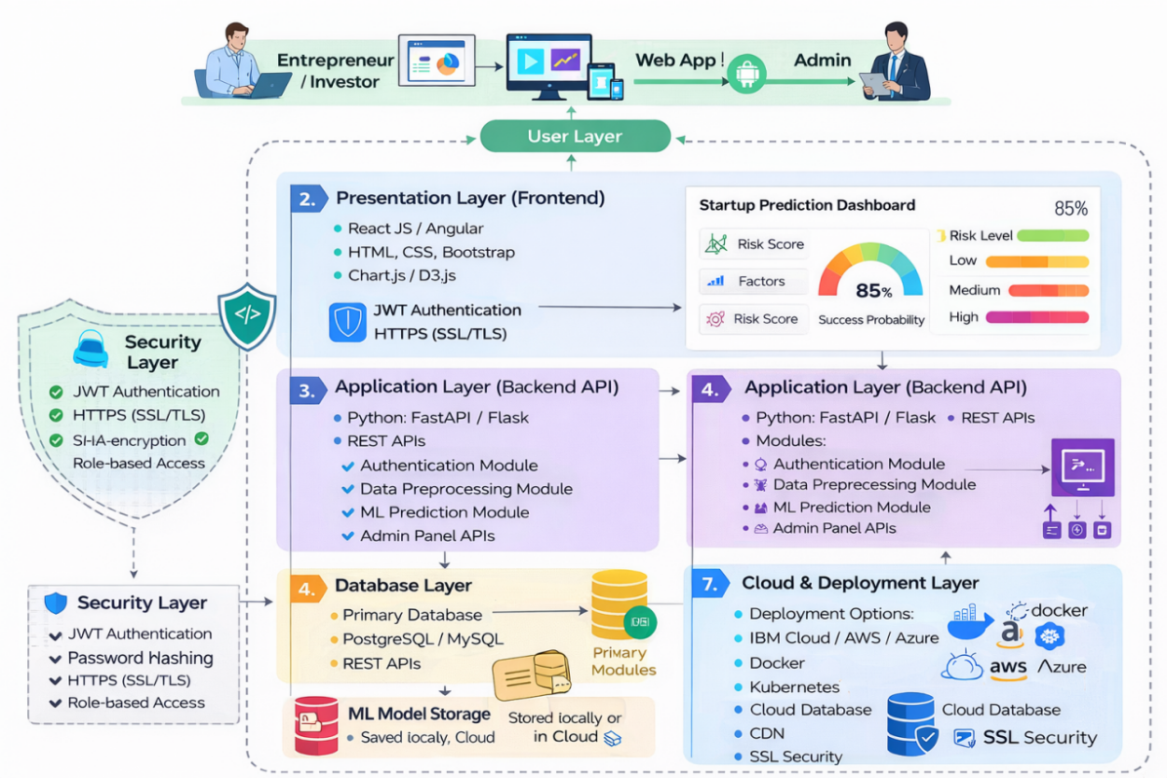
Figure 1: Architecture and data flow of the voice patient diary sample application

